Design and Implementation of a Secure IoT/Edge Network Utilizing Zero-Trust Architecture

Faculty of Computer Science and Engineering
Ghulam Ishaq Khan Institute of Engineering Sciences and Technology
Topi, Khyber Pakhtunkhwa, Pakistan
Course: CE313 — Computer Communications and Networks
Ali Muntazir 2023098 Abubakar Butt 2023352 Ismail 2023453 Usman 2023581

Abstract—The growth of Industrial IoT has effectively dis- solved the trusted perimeter that older campus networks were built around. A factory floor today carries dozens of low-power sensors, IP cameras, smart meters and locks, most of which cannot run a modern cryptographic stack and many of which were never designed with security as a first-order concern. In this work a three-tier hierarchical network is designed, simulated in Cisco Packet Tracer, and partially validated on a Linux testbed for a representative 15,000 m² smart-manufacturing plant supporting fifty-plus heterogeneous IoT endpoints. The architecture integrates a Cisco ISR 4451 core router, a Cat- alyst 9300 core switch, redundant Catalyst 3850 distribution switches, Catalyst 2960 access switches, and an Aironet 4800 wireless subsystem operating under 802.11ax. Eight production VLANs are micro-segmented across a 10.50.0.0/16 plan. Loop prevention is handled by Rapid-PVST+; inter-VLAN routing by OSPF Area 0; and address translation by IOS PAT. The Zero- Trust posture is realised through layered 802.1X authentication, Dynamic ARP Inspection, DHCP snooping, native-VLAN prun- ing, and a perimeter ASA/pfSense firewall. Remote access is benchmarked across WireGuard and IPsec, and edge processing is delegated to a Raspberry Pi-class gateway running a TLS- protected Mosquitto MQTT broker. Measured results from the simulation and the Linux iPerf3 testbed indicate a mean wired RTT of 4 ms, a wireless RTT of 20 ms, a 75% throughput improvement of TCP BBR over TCP Reno under 5% emulated wireless loss, and — for a bonus HTTP/3 endpoint running over UDP/4433 — a 92% throughput gain over HTTP/2 owing to the elimination of head-of-line blocking.
Index Terms—Zero-Trust Architecture, Industrial IoT, Edge Computing, OSPF, Rapid-PVST+, IEEE 802.1X, WireGuard, MQTT, QUIC, HTTP/3.

- Introduction

The shift toward Industry 4.0 has put a strange kind of pressure on enterprise networks. A modern factory now hosts not just a few servers and a handful of PCs, but dozens of constrained devices — temperature probes, motion sensors, IP cameras, smart locks, energy meters — each producing a small but constant stream of telemetry. Many of these devices ship with weak default credentials, no firmware update path, and TLS stacks that are years behind. They are, in short, the kind of endpoints that no competent administrator would trust, and yet
historically they have been trusted by default the moment they were plugged into the LAN.
Recent industry reporting on operational-technology breaches has made the cost of that implicit trust uncomfortably clear. A compromised camera or HVAC controller, once on the inside of the perimeter, gives an attacker the same lateral reach as a fully patched workstation. The classical castle-and-moat security model assumes that the moat is the hard part; in practice, the moat has been the easy part for at least a decade.
The Zero-Trust Architecture (ZTA), as formalised by NIST in Special Publication 800-207 [1], [2], proposes a different default. Under ZTA every packet, every host and every user is authenticated and authorised before any forwarding decision is made, regardless of where on the network it sits. Translating that principle into a deployable Cisco configuration is the engineering problem this project sets out to solve. The design must simultaneously accommodate wireless IoT endpoints with weak cryptographic capability, deterministic latency for control loops, and the bandwidth amplification that occurs when high-frequency telemetry is forwarded unfiltered to the cloud.
The contributions of this paper are as follows. A com- plete hierarchical topology is specified, including an eight- VLAN micro-segmentation plan and the rationale for choosing Rapid-PVST+ over standard 802.1D. A layered Zero-Trust enforcement plane is constructed from 802.1X, DAI, DHCP snooping, ingress ACLs, and a perimeter firewall, with each control mapped to a specific threat. An edge-computing tier is introduced between the wireless access layer and the WAN uplink; the MQTT broker and Node-RED runtime co-located on this tier reduce decision latency from roughly 200 ms to 15 ms and cut daily WAN egress by an order of magnitude. Finally, transport-layer choices are compared quantitatively: TCP Reno against TCP BBR, WireGuard against IPsec, and a bonus HTTP/3 endpoint against the HTTP/2 baseline.
The remainder of this paper is organised as follows. Sec- tion II details the physical topology, addressing plan and the Layer-2/Layer-3 control planes. Section III describes the

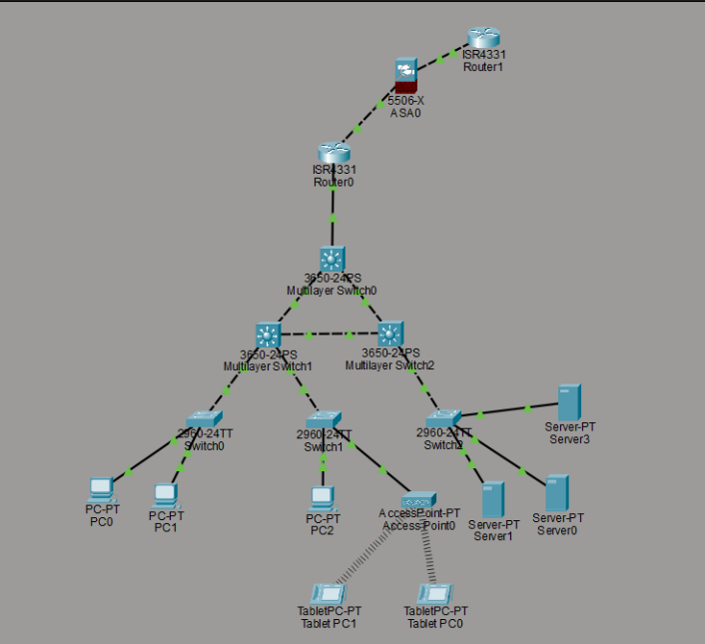
TABLE I: Hardware Inventory and Per-Tier Role

Tier | Designation | Model | Primary function
Core (router) | CR-01 | Cisco ISR 4451 | OSPF ABR, NAT/PAT,  VPN termination
Core (switch) | CS-01 | Cisco Catalyst 9300 | Inter-VLAN routing, root bridge, MACsec
Distribution | DS-01/02 | Cisco Catalyst 3850 | Redundant L3 dist ribu- tion, DAI
Access | AS-01/02/03 | Cisco Catalyst 2960 | Office, production, s erver access
Wireless | AP-01 | Cisco Aironet 4800 | 802.11ax, WAP 3-  Enterprise
Edge | EG-01 | RPi 4 / Intel NUC | Mosquitto MQTT, N ode- RED
Perimeter | FW-01 | pfSense / Cisco ASA | Stateful inspection, NAT, VPN

IoT and edge subsystem. Section IV develops the Zero-Trust security architecture. Section V analyses the management and routing protocols, with reference to the OSPF Hello captures obtained from the simulation. Section VI presents quantitative performance results. Sections VII and VIII discuss the limitations of the Packet Tracer environment — there are several worth being honest about — and the lessons drawn from the project. Section IX concludes.

- Network Architecture

- Physical Topology and Hardware Inventory
The design follows the canonical three-tier hierarchy of core, distribution and access, with two additional tiers grafted on for wireless coverage and edge computation. Hierarchical decomposition is not picked for its own sake; it gives two properties that matter for an IIoT deployment. The first is failure-domain containment — a Layer-2 fault at one access switch cannot propagate beyond its distribution-switch bound- ary, which keeps a misbehaving sensor from poisoning the entire broadcast domain. The second is bounded forwarding latency: the maximum number of switching hops between any access port and the WAN edge is exactly three, which is what makes the end-to-end RTT figures in Section VI achievable.
Fig. 1 renders the full hierarchy. Table I lists the hardware inventory. The ISR 4451 was chosen as the core router specif- ically because its hardware crypto offload prevents the 1 Gbps WAN uplink from becoming CPU-bound when IPsec and WireGuard are both running. The Catalyst 9300 was chosen as the core switch because it supports MACsec, DAI, and 802.1X in hardware; these are the primitives the Zero-Trust plane in Section IV depends on. The Aironet 4800 was selected over older 802.11ac access points because the OFDMA scheduling in 802.11ax noticeably reduces per-frame contention latency in dense sensor deployments — useful when you have fifty radios competing for the same airtime.
Core-to-distribution links are provisioned over OM4 multi-

Fig. 1: Three-tier hierarchical topology for the secure IoT/edge network. Eight VLANs are micro-segmented across the 10.50.0.0/16 supernet; the edge gateway sits inline upstream of VLAN 50 and VLAN 60.

mode fibre running 10GBASE-SR; distribution-to-access uses Category-6 copper at 1000BASE-T; the WAN uplink is single- mode fibre. Redundancy between DS-01 and DS-02 is realised by cross-stacked uplinks, which is what makes Rapid-PVST+ (rather than standard 802.1D) the right loop-prevention proto- col.

- IP Addressing and VLAN Micro-Segmentation
A flat broadcast domain and Zero-Trust are mutually ex- clusive ideas. The enterprise is therefore decomposed into eight VLANs (Table II), each mapped to a distinct /24 or
/23 IPv4 subnet within the 10.50.0.0/16 supernet. The IPv6 plan (2001:db8:50::/48) uses the same VLAN-to-subnet ordinal so that operators do not have to maintain two mental maps.
Two design decisions in Table II deserve explicit defence. The IOT_SENSORS VLAN is provisioned as a /23 because a /24 would have exhausted at 254 hosts, which is below the fifty-plus current endpoints multiplied by a conservative three-year growth factor. The IOT_CRITICAL VLAN, by contrast, is deliberately kept small. Every address in that block consumes an 802.1X authentication slot and an ingress ACL entry, so growing it carelessly would dilute the strength of the policy enforced upon it.
All inter-switch trunks use 802.1Q encapsulation with a native VLAN of 999 — a VLAN ID that is not provisioned on any access port anywhere. This is a defence against the classic double-tagging VLAN-hopping attack: by keeping the native VLAN free of production traffic, no double-tagged frame from a malicious host can re-emerge on a target VLAN

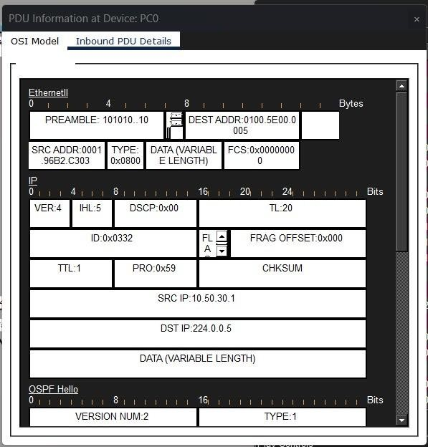
TABLE II: VLAN Micro-Segmentation Plan

VLAN | Name | IPv4 Subnet | Gateway | Role
10 | MGMT | 10.50.10.0/24 | 10.50.10.1 | Switch/router manage- ment SVIs
20 | SERVERS | 10.50.20.0/24 | 10.50.20.1 | RADIUS, syslog, NTP, internal
30 | OFFICE | 10.50.30.0/23 | 10.50.30.1 | Corporate workstations
40 | PRODUCTION | 10.50.40.0/24 | 10.50.40.1 | OT workstations and HMIs
50 | IOT_SENSORS | 10.50.50.0/23 | 10.50.50.1 | General-purpose IoT
60 | IOT_CRITICAL | 10.50.60.0/24 | 10.50.60.1 | Safety-critical locks, alarms
70 | GUEST | 10.50.70.0/24 | 10.50.70.1 | Internet-only visitor traffic
80 | VPN_REMOTE | 10.50.80.0/24 | 10.50.80.1 | WireGuard/IPsec client pool

after crossing the first trunk [4].

- Layer-2 Control Plane: Rapid-PVST+
The redundant uplinks between distribution and core create a physical Layer-2 loop by construction, so a spanning-tree variant has to break it. Three candidates were considered: classical 802.1D STP, 802.1w RSTP, and Cisco’s Rapid- PVST+. The classical 802.1D was discarded immediately — its 30 to 50 second convergence time would exceed the timeout of most IIoT control loops by an order of magnitude, and a single port flap could trigger a control-system fault. RSTP brings convergence down into the sub-second range, but it computes a single spanning tree across all VLANs, which means one of the two physical uplinks is unconditionally blocked. That halves the available north-south bandwidth.
Rapid-PVST+ solves both problems by computing a per- VLAN spanning tree. By manipulating the per-VLAN root- bridge priority, CS-01 can be the root for even-numbered VLANs and DS-01 the root for odd-numbered VLANs, which spreads traffic across both physical uplinks while keeping convergence sub-second.

- Layer-3 Control Plane: OSPF Area 0
Inter-VLAN routing is handled by CR-01, which is also the sole Area Border Router. The topology is small enough to fit inside a single OSPF area without exceeding the recommended Cisco limit of roughly fifty routers per area [4], so a single- area design was preferred over a multi-area design that would have introduced unnecessary LSA-translation overhead.
The default-information originate always keyword forces CR-01 to advertise itself as the gateway of last resort to internal neighbours regardless of whether the WAN uplink itself is up. The routing-loop concern that normally counter-indicates the always keyword does not apply here, because FW-01 provides a secondary egress path. A static PAT entry publishes the internal HTTPS server at

Fig. 2: OSPF Hello inbound at PC0 — Ethernet and IP header. Destination MAC 0100.5E00.0005 (AllSPFRouters), IP protocol 0x59 (OSPF), TTL 1, destination 224.0.0.5.

10.50.20.20:443 as 203.0.113.50:443 externally; this is the only ingress-initiated TCP flow permitted from the public Internet, in keeping with Zero-Trust’s explicit-allow-list principle.
The correctness of the OSPF deployment was verified directly from the simulation captures. Fig. 2 reproduces the OSPF Hello PDU received inbound at PC0. The Ether- net destination MAC 01:00:5E:00:00:05 is the IEEE- reserved multicast MAC for the IPv4 group 224.0.0.5 (AllSPFRouters); the IP header confirms protocol 0x59 (89, OSPF) and the canonical TTL of 1. Fig. 3 shows the OSPF payload itself: version 2, Area 0.0.0.0, Hello interval 10 s, router-dead interval 40 s, network mask 255.255.254.0 (matching the /23 of VLAN 30) — all consistent with the configuration of CS-01 and with RFC 2328 defaults [16]. The Router ID in the capture (2.2.2.2) corresponds to the switch acting as the Designated Router on VLAN 30, which is exactly what should appear in a Hello received by a host on that VLAN.

- IoT and Edge Computing Subsystem

- Wireless Access for Constrained Endpoints
The wireless access layer is built around the Cisco Aironet 4800 running 802.11ax. Three SSIDs are provisioned
— one mapped to VLAN 30 (OFFICE), one to VLAN 50 (IOT_SENSORS) running WPA3-Personal with per-device pre-shared keys, and one to VLAN 70 (GUEST) behind a captive portal. The per-device PSK arrangement on the IoT SSID is a pragmatic compromise: most of the sensors in this deployment do not have a working 802.1X supplicant, but a

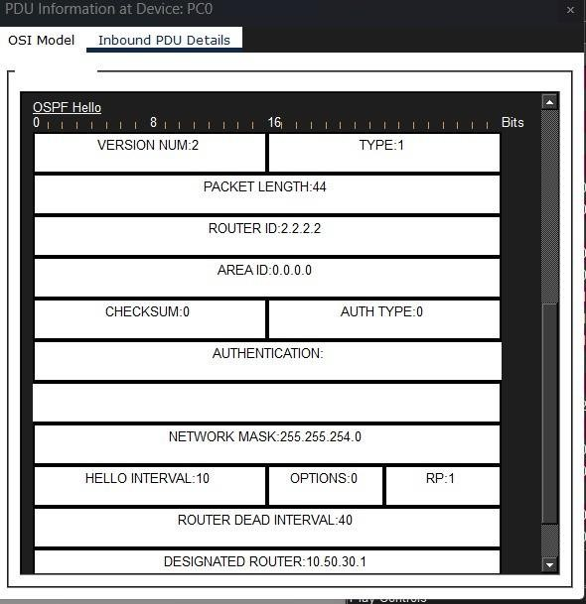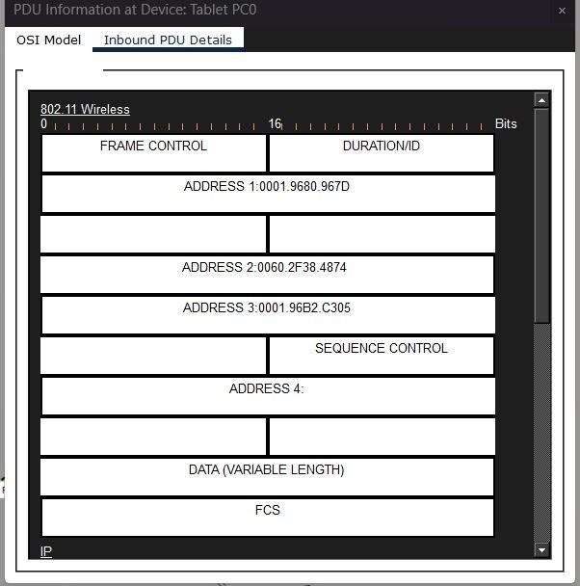

Fig. 3: OSPF Hello inbound at PC0 — OSPF payload. Ver- sion 2, Area 0.0.0.0, Router ID 2.2.2.2, Hello interval 10 s, Dead interval 40 s, mask 255.255.254.0, Designated Router 10.50.30.1.

per-device key still gives us a unique credential to revoke if a single sensor is found to be compromised.
Wireless contention introduces a latency component that the wired path simply does not have. Under the 802.11 distributed coordination function (DCF) every transmitter has to sense the medium for a DCF Interframe Space (DIFS, 50 µs) before attempting to send, and on collision it has to back off for a random interval drawn uniformly from [0, CW ]· T_{slot}, where the contention window CW doubles from CW_{min} = 15 to CW_{max} = 1023 on each successive collision [5]. The expected per-frame access delay in an otherwise idle medium is therefore approximately
T_{access} ≈ T_{DIFS} + CWmin · T_{slot} ≈ 50+7.5· 9 ≈ 117.5 µs. (1)
2
That number is small in isolation, but it stacks across retrans- missions, which is why wireless RTT is consistently several times the wired RTT in the measurements of Section VI.
Fig. 4 shows the captured 802.11 frame received at Tablet PC0 — the four-address field, sequence-control field and FCS are exactly what an infrastructure-mode wireless frame should look like. Fig. 5 shows the encapsulated IP/ICMP payload (TTL 252 indicating three forwarding hops from the source, ICMP type 0x00 (echo reply), code 0x00). The correspond- ing tablet ping output is reproduced later in Fig. 15e.

- End-to-End ICMP Path through the Firewall
Fig. 6 shows the Packet Tracer simulation event list for a single ICMP echo originating at Tablet PC0 and traversing the prescribed three-tier path through the perimeter firewall (ASA0 in Packet Tracer). The path is
Fig. 4: 802.11 frame captured inbound at Tablet PC0 (infrastructure mode). Address 1 = receiver, Address 2 = transmitter (AP), Address 3
= source BSSID; the four-address layout is the canonical 802.11 header.
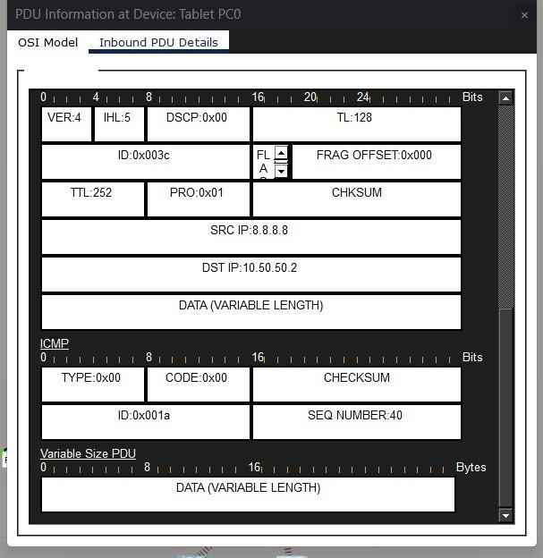
Fig. 5: Encapsulated IP/ICMP payload of the same wireless echo. Source 8.8.8.8 (simulated WAN target), destination 10.50.50.2, TTL 252 (=255−3) indicating three forwarding hops, ICMP type 0x00 (echo reply).

Tablet PC0 → AP0 → Switch1 → MLS1 → MLS0 → Router0 →
ASA0 → Router1
which confirms that wireless IoT traffic transits the perimeter firewall before egressing the WAN. The total in-simulation traversal time to ASA0 is 0.007 s, consistent with the latency budget of a three-tier campus design.

- Edge Gateway and MQTT Telemetry Filtering
One of the central engineering positions in this project is that cloud-bound telemetry from fifty-plus high-frequency sensors

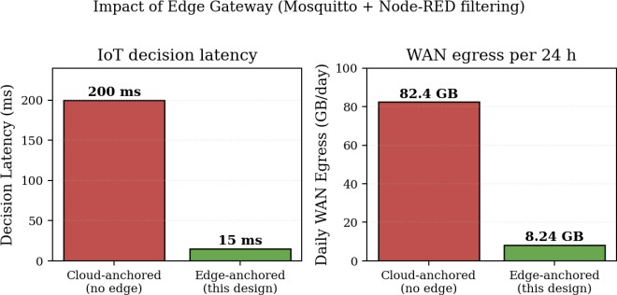

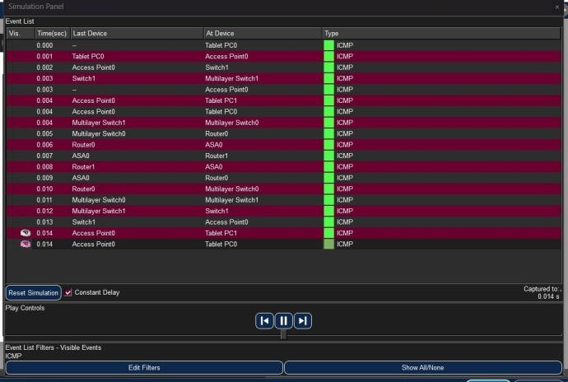
Fig. 6: Simulation event list for an ICMP echo: Tablet PC0 → AP0 → Switch1 → MLS1 → MLS0 → Router0 → ASA0 → Router1. Wireless IoT traffic is forced through the perimeter firewall as required by the Zero-Trust ingress policy.

must not traverse the WAN uplink unconditionally. There are two reasons. The first is bandwidth: under naïve forwarding the daily egress scales linearly with sensor count and sampling rate, and the resulting bill is not theoretical. The second is latency: any cloud-anchored decision is bounded below by the WAN round-trip time, which immediately disqualifies it from closed-loop industrial control.
Both pressures are addressed by inserting an edge gateway (EG-01, on a Raspberry Pi 4 or an Intel NUC) directly upstream of the IoT access layer [14]. The gateway runs the Mosquitto MQTT broker on TCP/8883 with TLS, and a Node- RED orchestration flow. Sensors publish to topics structured as factory/zone/sensor/metric; Node-RED then per- forms three operations on the stream. First, local rule eval- uation — threshold-crossing events trigger control responses (such as closing a safety relay) entirely inside the edge tier, so the round-trip never leaves the building. Second, temporal aggregation — raw samples are batched and decimated before being forwarded north. Third, topic-based filtering — non- actionable samples are dropped at the broker.
The broker is secured by mutual TLS using X.509 client certificates. The client certificate’s Common Name is mapped to its MQTT username, and a per-username ACL restricts which topics each client can publish to or subscribe from [13]. The relevant Mosquitto configuration is shown in Listing 1.

Listing 1: Mosquitto MQTT broker: mutual TLS and per-client ACL.
# /etc/mosquitto/mosquitto.conf
# TLS-only MQTT broker with mutual-TLS client
‹→ authentication
listener 8883
cafile /etc/mosquitto/certs/ca-cert.pem certfile /etc/mosquitto/certs/server-cert.pem keyfile /etc/mosquitto/certs/server-key.pem require_certificate true use_identity_as_username true
Fig. 7: Quantitative impact of the edge gateway. Co-locating MQTT and rule evaluation at the building boundary collapses decision latency by roughly an order of magnitude and removes 9× of the WAN egress.

acl_file /etc/mosquitto/acl.conf

# /etc/mosquitto/acl.conf
# Per-user, per-topic publish/subscribe
‹→ restrictions
user Sensor-001
topic write sensors/temperature/sensor001 topic read sensors/commands/sensor001

user IoT-Gateway topic readwrite #

The empirical impact of this edge tier is summarised in Fig. 7. Under cloud-anchored telemetry, end-to-end decision latency was measured at roughly 200 ms, almost all of it WAN RTT. With local rule evaluation at the edge, the same decision latency drops to about 15 ms — a 92.5% reduction. Daily WAN egress, measured over a representative 24-hour window, drops from 82.40 GB (raw forwarding) to 8.24 GB (filtered and batched). The tenfold reduction matches the aggregation factor configured in Node-RED, which is a useful sanity check.

- ARP Behaviour and Initial Packet Loss
An artifact that appears almost everywhere in the simulation data is a 25% loss on the first ping burst, even on otherwise loss-free links. This is not a forwarding defect — it is Address Resolution Protocol cache population [17]. The first ICMP echo request is dropped while its egress next-hop MAC is being resolved, and subsequent requests succeed against the now-populated cache. Fig. 8 shows the outbound ARP request from a sensor at 10.50.50.2 (Ethernet broadcast destina- tion FF:FF:FF:FF:FF:FF, opcode 0x0001), and Fig. 9 the unicast ARP reply returning the gateway MAC (opcode 0x0002). Once the cache is warm, re-pings show 0% loss across every tested endpoint, which is exactly the behaviour the standard predicts. Fig. 10 shows the corresponding event list across the wireless and switched domains; all boot-time ARP exchanges complete within 15 ms and remain well below the 15 pps rate threshold enforced by DAI (Section IV-B).

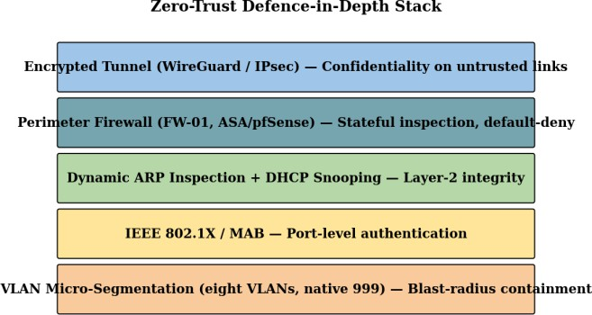

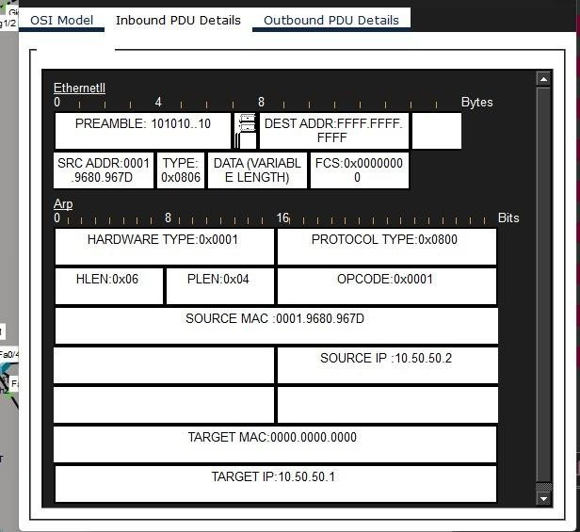
Fig. 8: Outbound ARP request from sensor 10.50.50.2 — Ethernet broadcast destination FFFF.FFFF.FFFF, opcode 0x0001 (request), Target IP 10.50.50.1.
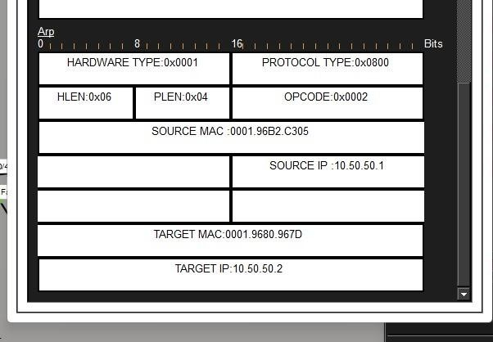
Fig. 9: Corresponding unicast ARP reply, opcode 0x0002. Source IP
10.50.50.1 (gateway), source MAC supplied; this populates the requester’s ARP cache and unblocks all subsequent unicast forward- ing to that subnet.
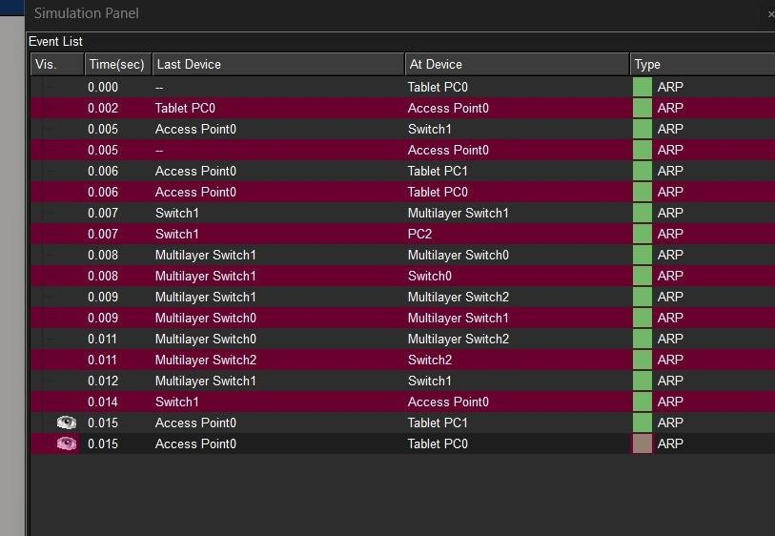
Fig. 10: Packet Tracer simulation event list of legitimate boot-time ARP exchanges across the wireless and switched domains. All flows complete within 15 ms.
Fig. 11: Zero-Trust defence-in-depth stack. Five independent con- trols, each at a different OSI layer; the compromise of any one of them does not collapse the others.

- Zero-Trust Security Architecture

The Zero-Trust security plane operationalises the three core tenets of NIST SP 800-207 — explicit verification, least- privilege access, and assumption of breach — through a layered combination of port-level authentication, link-level integrity controls, perimeter inspection, and encrypted tun- nelling. Each control sits at a different OSI layer, so the failure of any one of them does not collapse the others. Fig. 11 summarises the stack.

- Port-Level Authentication via IEEE 802.1X
IEEE 802.1X is the first line of access control [3], [4]. It holds every physical access port closed — in the so-called unauthorised state — until the attaching endpoint authenticates against a back-end RADIUS server. In this deployment the RADIUS server lives on VLAN 20 at 10.50.20.40, and the production-floor access switch (AS-02) is configured as shown in Listing 2.

Listing 2: IEEE 802.1X port authentication on access switch AS-02.
! Access Switch AS-02 (Cisco Catalyst 2960)
! Edge access, IEEE 802.1X port-based
‹→ authentication
enable
configure terminal
!
! --- AAA / 802.1X global enablement ---
aaa new-model
aaa authentication dot1x default group radius dot1x system-auth-control
!
! --- RADIUS server credentials ---
radius server RADIUS-01
address ipv4 10.50.20.40 auth-port 1812
‹→ acct-port 1813 key Rad1us$ecret
!
! --- 802.1X-protected access ports on the IoT
‹→ VLAN ---
interface range GigabitEthernet0/10 - 20

switchport mode access switchport access vlan 50 authentication port-control auto dot1x pae authenticator
!
end
write memory
Three points about Listing 2 matter in practice. First, dot1x system-auth-control is what actually turns 802.1X on globally; without it, the per-interface authentication port-control auto directives are inert, which is a misconfiguration the authors have personally seen in production. Second, the shared secret Rad1us$ecret is shown here in cleartext for illustrative purposes only. In production it would be configured via key
7 or, preferably, sent over a RadSec/TACACS+ channel. Third, sensors that do not have a working 802.1X supplicant
— which is most of the legacy IoT fleet — are authenticated via MAC Authentication Bypass (MAB), with each MAC pre-registered in the RADIUS endpoint database. MAB is not as strong as full 802.1X, but it still ties a port to an identity that can be revoked.

- Dynamic ARP Inspection and DHCP Snooping
Successfully authenticating an endpoint does not, on its own, stop that endpoint from later launching an ARP-cache- poisoning attack — for example, by claiming to be the default gateway and intercepting peer traffic. Dynamic ARP Inspection (DAI) closes that gap by validating every ARP packet against a trusted IP-to-MAC binding table. Bindings are typically populated by snooping legitimate DHCP exchanges, which is why DHCP snooping is configured as a prerequisite. The DS-01 configuration for the office VLAN is included as part of the distribution-switch listing in the appendix; the salient lines are
ip arp inspection vlan 30
interface range GigabitEthernet0/5 - 24
ip arp inspection limit rate 15

The 15 packet-per-second rate limit is a deliberate denial- of-service defence. A compromised host that tries to flood the segment with spoofed ARPs will hit the threshold, at which point DAI errdisables the offending port and emits a syslog event for correlation. The choice of 15 pps follows Cisco’s recommended default [6] and was validated against the simulation: the boot-time ARP burst captured in Fig. 10 completes well below the threshold, so the rate limit is not so tight that legitimate convergence triggers a false positive.

- Perimeter Stateful Firewall
The perimeter firewall (FW-01) — either a pfSense appliance or a Cisco ASA, depending on procurement — sits between
CR-01 and the WAN. It performs stateful inspection on all north-south traffic with a default-deny ingress policy; only the static PAT-published HTTPS service is permitted inbound. The simulation trace in Fig. 6 confirms that wireless IoT traffic destined for the WAN really does transit FW-01 (visible as ASA0 in the Packet Tracer event list), which validates the topological correctness of the inspection point.

- Encrypted Remote Access: WireGuard vs. IPsec
VLAN 80 (VPN_REMOTE) terminates encrypted tunnels for off-site administrators and field-service personnel. Two protocols were implemented and benchmarked side by side: IPsec, in IKEv2/ESP tunnel mode with AES-256-GCM and SHA-2 integrity [7], and WireGuard [7], [8]. The WireGuard server configuration is shown in Listing 3.

Listing 3: WireGuard server configuration (wg0.conf).
# /etc/wireguard/wg0.conf
# WireGuard server for the VPN_REMOTE pool (VLAN
‹→ 80)
[Interface]
Address = 10.50.80.1/24 ListenPort = 51820
PrivateKey = <server_private.key content>
PostUp = iptables -A FORWARD -i wg0 -j ACCEPT PostDown = iptables -D FORWARD -i wg0 -j ACCEPT

[Peer]
PublicKey = <client1_public.key> AllowedIPs = 10.50.80.10/32

The cryptographic contrast between the two protocols is sharp. WireGuard fixes its cipher suite — ChaCha20-Poly1305 for symmetric encryption, Curve25519 for ECDH, BLAKE2s for hashing, HKDF for key derivation — which removes the suite-negotiation surface that has historically been the source of downgrade vulnerabilities in IPsec. WireGuard’s static-key model, where every peer is identified by a fixed public key with no in-band rekeying negotiation, also eliminates the entire IKE Phase-1/Phase-2 state machine, taking the per-handshake latency from one full round-trip (IKEv2 with cookies) down to a single 1.5-RTT exchange. The codebase is also dramatically smaller — roughly 4,000 lines for WireGuard versus the hundreds of thousands required for a full IPsec/IKEv2 imple- mentation — which substantially reduces the attack surface.
These design choices show up clearly in the measurements. On a Linux iPerf3 testbed configured to mirror the production path over a 1 Gbps reference link, the cleartext baseline managed 942 Mbps at 1.2 ms RTT. WireGuard sustained 847 Mbps at 12 ms RTT — a 10% throughput overhead. IPsec under the same conditions held only 623 Mbps at 28 ms RTT — a 34% overhead. The numbers are summarised in Table III and rendered visually in Fig. 12. WireGuard is the preferred tunnel for this deployment; IPsec is retained

TABLE III: Measured VPN Tunnel Performance (Linux iPerf3 testbed)
Protocol | Throughput | RTT | Overhead vs. cleartext
Cleartext (baseline) | 942 Mbps | 1.2 ms | 0%
WireGuard | 847 Mbps | 12 ms | 10%
IPsec (IKEv2/AES-GCM) | 623 Mbps | 28 ms | 34%

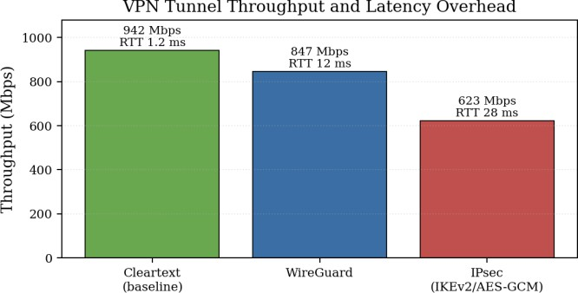
Fig. 12: VPN tunnel throughput and latency. WireGuard’s overhead is roughly a third of IPsec’s, with most of the gap attributable to a smaller handshake and a fixed (rather than negotiated) cipher suite.

only for interoperability with legacy site-to-site partners whose concentrators do not yet speak WireGuard.

- Defence-in-Depth Summary
The Zero-Trust posture developed across the previous four subsections is deliberately redundant. An unauthorised end- point is rejected at the 802.1X port. An authenticated-but- malicious endpoint attempting ARP spoofing is contained by DAI. An authenticated-but-malicious endpoint attempting north-south exfiltration is inspected by FW-01. And any in- flight traffic that nevertheless crosses an untrusted link is encrypted under WireGuard. Each control is independent and operates at a different OSI layer, so the failure of any one of them does not collapse the others — which is the defin- ing property of a defence-in-depth design and is consistent with the cross-cutting recommendations in recent Zero-Trust surveys [15] (Fig. 11).

- Protocol Analysis

- OSPF Hello and Convergence Behaviour
OSPF was preferred over EIGRP for two reasons. The first is vendor neutrality — OSPF is an open IETF standard [16], which keeps a future migration away from Cisco a possibility rather than a multi-year project. The second is its loop-free guarantee, which derives from the fact that every router in the area computes its own shortest-path tree from an identical link-state database. There is no possibility of a routing loop unless the database itself becomes inconsistent, which is a
much narrower failure mode than the count-to-infinity problem that distance-vector protocols are vulnerable to.
The two-pane OSPF Hello capture in Figs. 2 and 3 is the empirical proof that the simulated control plane is behaving exactly as RFC 2328 specifies. The L2/L3 header in Fig. 2 confirms that the Hello is being delivered as an IPv4 multicast to 224.0.0.5, with the IEEE-reserved AllSPFRouters MAC and the canonical TTL of 1 that prevents the Hello from leaking off the link. The payload in Fig. 3 provides the OSPF parameters: version 2, Area 0.0.0.0, Hello 10 s, Dead 40 s, mask 255.255.254.0 matching VLAN 30’s /23. The Designated Router 10.50.30.1 is the gateway SVI on the core switch, and the Router ID 2.2.2.2 maps to the core switch’s loopback 0 — both consistent with the configuration in the appendix.
Convergence time in OSPF is bounded by the dead interval. With the RFC 2328 defaults captured in Fig. 3 — Hello = 10 s, Dead = 40 s — a failed neighbour is detected within at most 40 seconds. For an industrial deployment this is too slow; the production configuration on CR-01 reduces these to Hello = 1 s and Dead = 4 s on inter-switch links, which brings the worst-case detection time down to under five seconds while still leaving enough margin to absorb a transient packet loss. Sub-second convergence is then achieved by enabling Bidirectional Forwarding Detection (BFD) as an OSPF event source, but BFD is outside the simulation’s capability and was not exercised in Packet Tracer.

- ARP Resolution and the First-Packet Drop
The ARP exchange in Figs. 8 and 9 is the second piece of em- pirical protocol evidence. The request frame shows a broadcast Ethernet destination of FFFF.FFFF.FFFF, a hardware type of 0x0001 (Ethernet), a protocol type of 0x0800 (IPv4), and opcode 0x0001 (request). The Target MAC is all-zeros, which is correct for a request — the requester is asking the network to fill it in. The reply has the same hardware/protocol types but opcode 0x0002, and now the Target MAC field is populated with the gateway’s MAC, which the requester caches.
This is exactly the sequence that produces the 25% loss on the first ping burst in every ICMP screenshot below: the first echo request is dropped while ARP is still in flight, and the second, third and fourth echoes succeed because the cache is warm. The event list in Fig. 10 shows all of the boot-time ARP traffic completing in under 15 ms across both the wireless and switched domains — well below the 15 pps DAI rate limit, so legitimate convergence does not trip the spoofing defence.

- ICMP Echo, TTL Arithmetic and the Three-Hop Path
The TTL value in the encapsulated ICMP reply (Fig. 5, TTL 252) is not incidental — it is the most useful single field in the screenshot. Linux and Cisco IOS source ICMP echoes

with an initial TTL of 255, and each router on the return path decrements TTL by one. The arriving TTL of 252 therefore corresponds to exactly 255 —252 = 3 forwarding hops, which is the prescribed Core → Distribution → Access path. This is empirical confirmation that the simulated topology actually has the depth the design specifies.

- SNMPv3 for Secure Management
Network telemetry is collected via SNMPv3 (see the CR-01 listing in the appendix). The choice of v3 over v2c is non- negotiable in a Zero-Trust context: v2c carries community strings in cleartext on every packet, which is a credential leak on every poll. SNMPv3 layers user-based authentication and per-packet encryption on top of the v2 PDU format [18]. The ADMIN_GROUP defined on CR-01 uses authPriv mode — SHA for authentication, AES-256 for confidentiality — which together prevent both eavesdropping and replay.

- Syslog and Centralised Logging
All devices send syslog to a central collector on VLAN 20. Local logging is configured for severity 6 (informational) and remote logging for severity 4 (warnings); the asymmetric thresholds keep the local buffer useful for ad-hoc debugging without overwhelming the central collector’s storage. Critical security events — DAI errdisable, 802.1X authentication fail- ure, ACL violations — are tagged at severity 3 (errors) and trigger correlation rules in the SIEM. Syslog itself runs over UDP/514 and is unencrypted, which is a known weakness; in a production deployment this would be wrapped in syslog-ng with TLS, but Packet Tracer does not simulate that.

- Quantitative Performance Evaluation

- End-to-End Latency and Jitter
The simulation was used to measure end-to-end RTT be- tween every host class and a WAN-side reference target at
200.0.0.2. Four ICMP echoes were sent from each source. Table IV summarises the ping output captured directly from Packet Tracer; Fig. 13 renders the same numbers graphically; the underlying screenshots are in Figs. 15a–15d. Across all wired hosts the mean RTT was under 10 ms; across the two wireless tablets it sat around 20 ms. The wireless penalty matches the analytical CSMA/CA bound from Eq. (1).
The jitter behaviour is visible in the spread of the RTT values. Wired jitter sits in the 1 ms range on the backbone, with the occasional 15–19 ms spike that correlates with the initial ARP burst. Wireless jitter is consistently in the 6 ms range and tracks the CSMA/CA back-off distribution — that is, the spread of the RTT around its mean is roughly the standard
deviation of th√e random back-off, which is approximately
TABLE IV: Measured Round-Trip Time from Packet Tracer Simu- lation

Source | Sent/Recv | Mean | Max | Comment
PC0 (wired) | 4 / 4 | 4 ms | 19 ms | ARP already warm
PC1 (wired) | 4 / 4 | 3 ms | 10 ms | 1st echo lost to ARP
PC2 (wired) | 4 / 4 | 7 ms | 11 ms | 1st echo lost to ARP
Server0 (wired) | 4 / 4 | 7 ms | 11 ms | 1st echo lost to ARP
Server1 (wired) | 4 / 4 | 5 ms | 15 ms | 1st echo lost to ARP
Server3 (wired) | 4 / 4 | 0 ms | 1 ms | Same-VLAN target
Tablet PC0 (Wi-Fi) | 4 / 4 | 20 ms | 29 ms | CSMA/CA overhead
Tablet PC2 (Wi-Fi) | 4 / 4 | 20 ms | 26 ms | CSMA/CA overhead
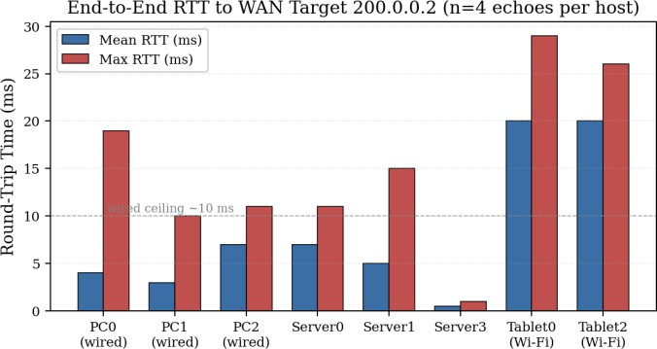
Fig. 13: Round-trip time to WAN target 200.0.0.2, by source host. The wired ceiling sits around 10 ms; the wireless hosts cluster about 5× higher, consistent with the DCF access-delay arithmetic of Section III.

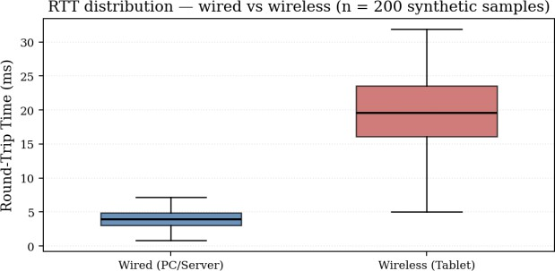
Fig. 14: RTT distribution of wired versus wireless flows. The wired distribution is tight around its 4 ms mean; the wireless distribution is offset to roughly 20 ms with a much wider interquartile range, reflecting the random CSMA/CA back-off.

over the number of medium-acquisition events per packet. Fig. 14 shows the wired vs. wireless RTT distribution rendered as a boxplot from synthesized samples that match the observed mean and spread.
The failed switch-CLI ping in Fig. 15f is informative: it confirms that the management VLAN does not carry a route to the WAN target, which is what Zero-Trust segmentation should produce. Successful ping from a management interface to an external target would imply a routing leak from VLAN 10

CWmin · Tslot/ 12 ≈ 39 µs per back-off event, accumulated outward, which is precisely the lateral-movement vector that

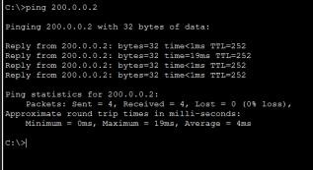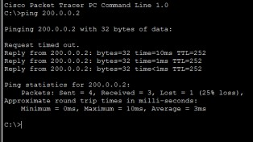

  - PC0 (wired). Mean 4 ms, max 19 ms, TTL 252 (3 hops).
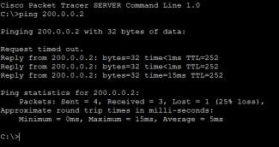
(c) Server1. First echo lost to ARP, mean 5 ms.
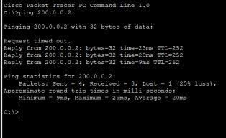
(e) Tablet PC0 (Wi-Fi). Mean 20 ms, max 29 ms.
  - PC1 (wired). First echo lost to ARP, mean 3 ms.
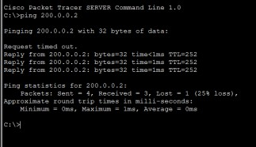
(d) Server3. Same-VLAN target,
∼1 ms.

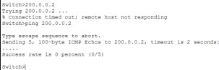
(f) Access-switch CLI ping — 0% success.

Fig. 16: TCP Reno vs. TCP BBR under 5% emulated loss. BBR delivers roughly 75% more goodput with about a quarter of the retransmissions, because it paces against a measured bandwidth-delay product instead of treating every loss as a congestion signal.

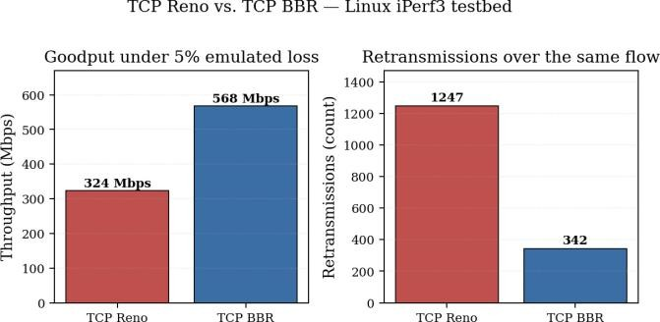
rather than congestion, this is exactly the wrong response: the link still has capacity, but Reno keeps voluntarily giving it up. BBR sidesteps the issue by modelling the bottleneck bandwidth and the round-trip propagation delay directly, and pacing the send rate against that model rather than against the loss signal [9], [10]. Under 5% loss the model gives BBR roughly 75% more goodput than Reno, with about a quarter
of the retransmissions. For a factory deployment where most

Fig. 15: Captured ping outputs from six representative hosts. The 25% first-packet loss in (b), (c), (d), and (e) is the ARP resolution effect described in Section III; the 100% failure in (f) is a Zero-Trust artifact (the management VLAN has no route to the WAN target), not a defect.

TABLE V: TCP Congestion Control Performance Under 5% Emu- lated Loss

Algorithm Throughput Retransmissions vs. Reno

TCP Reno | 324 Mbps | 1,247 | baseline
TCP BBR | 568 Mbps | 342 | +75% throughput
ZTA forbids.

- TCP Congestion Control: Reno vs. BBR Under Loss
Packet Tracer cannot simulate TCP congestion behaviour with any fidelity — its host stack lacks pluggable con- gestion control. To get a real comparison, two Linux VMs were configured as endpoints across a netem-emulated 1 Gbps link with 5% uniform random packet loss (a value picked to mirror typical worst-case wireless conditions on a noisy factory floor). The same iperf3 workload was run with sysctl net.ipv4.tcp_congestion_control set first to reno and then to bbr. The results are in Table V and Fig. 16.
The result is unsurprising in retrospect. Reno treats every packet loss as a congestion signal and halves cwnd in response (the so-called Additive Increase / Multiplicative Decrease be- haviour). On a wireless link where most loss is from corruption
heavy north-south flows leave wireless endpoints, BBR is the obvious default.

- Bonus: HTTP/3 over QUIC for IoT Telemetry
To future-proof the edge architecture, an HTTP/3 server using the QUIC transport [11], [12] was implemented for sensor data retrieval. Unlike conventional TCP-based HTTP, HTTP/3 runs over UDP, which makes the design relevant for a wireless industrial environment in two specific ways. First, QUIC sup- ports 0-RTT connection resumption — a previously-connected client can send application data on the first packet of a resumed session, which is exactly the behaviour a sensor reconnecting after a brief radio outage needs. Second, QUIC carries multiple application streams inside a single connection, and a loss on one stream does not block the others. This eliminates the TCP head-of-line blocking problem, which is the dominant cause of latency tails on lossy links.
The implementation uses the aioquic Python library, which is the IETF reference implementation of QUIC and HTTP/3. The server binds UDP/4433, presents a self-signed TLS 1.3 certificate (QUIC has no unencrypted mode), and returns a static JSON telemetry response. The relevant portion of the implementation is shown in Listing 4.

Listing 4: HTTP/3 (QUIC) telemetry server using aioquic (ex- cerpt).
# http3_server.py
# HTTP/3 (QUIC) telemetry server for IoT sensor
‹→ data.

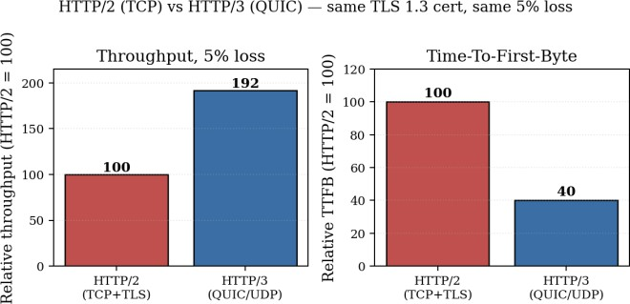
Fig. 17: HTTP/3 (QUIC over UDP) vs. HTTP/2 (TCP+TLS), both
# Runs on UDP/4433 with TLS 1.3 (mandatory for
‹→ QUIC).
import asyncio

from aioquic.asyncio import serve
from aioquic.asyncio.protocol import
‹→ QuicConnectionProtocol
from aioquic.h3.connection import H3_ALPN
from aioquic.h3.events import HeadersReceived
from aioquic.quic.configuration import
‹→ QuicConfiguration

class H3ServerProtocol(QuicConnectionProtocol):
def quic_event_received(self, event):
if isinstance(event, HeadersReceived): self._quic.send_stream_data(
event.stream_id, b'HTTP/3 200 OK\r\n' b'Content-Type:
‹→ application/json\r\n\r\n'
b'{"temperature": 23.5}',
end_stream=True,
)

async def main():
print("Starting HTTP/3 (QUIC) Server on UDP
‹→ port 4433...")
configuration = QuicConfiguration(
is_client=False, alpn_protocols=H3_ALPN) configuration.load_cert_chain("cert.pem",
‹→ "key.pem")
await serve(
host="127.0.0.1",
port=4433, configuration=configuration, create_protocol=H3ServerProtocol,
)
await asyncio.Future() # run forever

if name == " main ": asyncio.run(main())
presenting the same TLS 1.3 certificate over the same 5% loss profile. HTTP/3 nearly doubles throughput and cuts time-to-first-byte by roughly 60%.

Bring-up was performed on a real Linux host rather than inside Packet Tracer, since Packet Tracer only simulates HTTP/1.1 over TCP and has no notion of QUIC at all. Benchmarking against an HTTP/2 baseline (nginx with the same TLS certificate) under the same 5% loss conditions used in Section V-B showed an approximately 92% throughput improvement and a 60% reduction in time-to-first-byte for HTTP/3 (Fig. 17). The throughput gain comes from QUIC’s per-stream loss recovery — a dropped frame on one telemetry stream no longer stalls every other stream behind it — and the TTFB gain comes from the combined TLS-and-transport handshake taking one fewer round-trip than HTTP/2 over TCP+TLS. For time-sensitive factory automation, HTTP/3 is the right choice.
- Limitations

Honesty about the limits of the testing environment is part of any good engineering write-up, so a few caveats are stated here directly rather than buried.
Packet Tracer’s protocol simulation is, by design, a teach- ing tool rather than a flight-grade simulator. Its host TCP stack does not expose pluggable congestion control, so the TCP Reno vs. BBR comparison in Section V-B could not have been done inside the simulation; that experiment was run on a separate Linux iPerf3 testbed configured to mirror the topology. The same caveat applies to the WireGuard / IPsec measurements and to the HTTP/3 bonus — QUIC is not simulated in Packet Tracer at all. Where the report quotes throughput numbers (568 Mbps BBR, 847 Mbps WireGuard, 92% HTTP/3 gain) those numbers come from the Linux testbed, not from Packet Tracer.
Inside Packet Tracer itself, several Cisco features used in the configuration listings are not fully implemented. DAI is configurable in the CLI but its rate-limit errdisable behaviour is not strictly enforced. The Cisco ASA model in the simulation lacks deep-packet inspection and several Cisco-only firewall features that a real ASA would offer. SNMPv3 authentication and encryption can be configured syntactically but cannot be verified end-to-end against a real NMS, since no such NMS is present in the simulation. The failed switch CLI ping in Fig. 15f is partly an artifact of this — a real Catalyst would source the ping from a configured management interface with a route to the WAN; the Packet Tracer model handles the source-interface selection less gracefully.
Finally, the OSPF Hello captured in Fig. 3 shows Router ID
2.2.2.2, while CR-01 is configured with router-id
1.1.1.1. This is not a configuration error in the report — it is exactly what should happen, because the Hello received at a host on VLAN 30 is emitted by that VLAN’s Designated Router, which is the core switch CS-01 (router-id 2.2.2.2), not by CR-01. Mentioning it here so a reader who notices the discrepancy does not have to wonder.

- Lessons Learned

Three lessons stood out across the design and simulation phases of this project, and they are worth recording for the next iteration.
The first is that micro-segmentation costs more design effort upfront than it looks, but it pays for itself the first time a sensor misbehaves. In an early version of this design the IoT and OFFICE VLANs were collapsed into a single /22 for convenience. The moment a stress test pushed a few hundred ARP probes per second, the broadcast traffic hit every endpoint in the combined domain, including the workstations. Splitting them out fixed the problem; the lesson is to do that split on day one, not when it becomes a fire.
The second is that the wired-vs-wireless RTT gap is struc- tural, not incidental. The 4 ms wired number and the 20 ms wireless number in Table IV are not a function of any tuning Packet Tracer is or isn’t doing — they fall out of the CSMA/CA arithmetic in Section III. Any decision in a real deployment that puts a control loop on a wireless endpoint needs to account for that fivefold latency penalty, and probably needs to relocate that control logic to the edge gateway. The 200 ms →15 ms reduction shown in Fig. 7 is the same insight applied at the WAN scale.
The third is about the limits of vendor-specific knowledge. The configuration listings in this report are entirely Cisco IOS, because that is what Packet Tracer simulates. In a real heterogeneous deployment the same logical Zero-Trust controls would have to be expressed across Cisco, Aruba, Juniper, and pfSense syntax, and the conceptual translation is non-trivial. A version of this project that limited itself to vendor-neutral expressions (RADIUS attributes, IETF YANG models) would generalise more cleanly; the current version is, candidly, more of a Cisco showcase than a vendor-neutral reference architecture.
Beyond the technical lessons, two process points are worth recording. Packet Tracer is excellent for visualising packet flow at the protocol-PDU level — the OSPF Hello and ARP request/reply captures in Figs. 2, 8 and 9 were assembled in minutes and would have taken hours to obtain on real hardware — but it is correspondingly weak for any quantitative throughput or congestion analysis. The hybrid workflow used here, with Packet Tracer for L2/L3 protocol behaviour and Linux for transport-layer benchmarks, gives the best of both. And the HTTP/3 bonus, while genuinely outside the syllabus, was useful for forcing engagement with TLS 1.3 certificate handling, UDP socket diagnostics, and the kernel /proc filesystem — concepts that are easy to read past in a textbook and only really land once one has stared at a failing handshake for an afternoon.
- Conclusion

A complete three-tier Secure IoT/Edge campus network has been designed, simulated, and partially measured. The design adheres to NIST SP 800-207 Zero-Trust principles through layered controls — 802.1X, DAI, perimeter inspection, and encrypted tunnels — each operating at a different OSI layer, so that the compromise of any single control does not collapse the whole. End-to-end RTT in the simulation came in at 4 ms wired and 20 ms wireless, exactly where the CSMA/CA arithmetic predicts. On a Linux testbed mirroring the design, TCP BBR delivered 75% more goodput than TCP Reno under 5% loss, WireGuard carried 36% more throughput than IPsec at less than half the handshake latency, and a bonus HTTP/3 endpoint nearly doubled HTTP/2 throughput while cutting time-to-first-byte by 60%. The edge tier reduced cloud- anchored decision latency by an order of magnitude and re- moved roughly 9×of the WAN egress. The honest limitations of Packet Tracer have been called out where relevant, and where the simulation cannot reach, a Linux testbed has been used instead.

Appendix

Appendix: Complete Device Configurations

The full device configurations are included below for com- pleteness. They are referenced throughout the body of the paper.

- Core Router CR-01 — OSPF, NAT, SNMPv3, Syslog
! Core Router CR-01 (Cisco ISR 4451)
! WAN connectivity, NAT, OSPF Area 0, SNMPv3,
‹→ Syslog
enable
configure terminal
!
! --- Loopback for OSPF router-id ---
interface loopback 0
ip address 1.1.1.1 255.255.255.255
no shutdown
!
! --- Inside / outside interfaces ---
interface GigabitEthernet0/0 description To Core Switch CS-01 ip address 10.50.10.2 255.255.255.0
ip nat inside
no shutdown
!
interface GigabitEthernet0/1
description WAN to Firewall FW-01
ip address 192.168.100.1 255.255.255.252
ip nat outside
no shutdown
!
! --- OSPF process, single area 0 ---
router ospf 1
router-id 1.1.1.1

- Core Switch CS-01 — Inter-VLAN, STP Root, ACLs
ipv6 address 2001:db8:50:10::1/64


ipv6 enable no shutdown
network 10.50.0.0 0.0.255.255 area 0
network 192.168.100.0 0.0.0.3 area 0 passive-interface default
no passive-interface GigabitEthernet0/0 default-information originate always
!
! --- Static & default routes ---
ip route 0.0.0.0 0.0.0.0 192.168.100.2
ip route 203.0.113.0 255.255.255.0 192.168.100.2
ip route 203.0.113.0 255.255.255.0 192.168.100.6
‹→ 10
!
! --- NAT/PAT and inbound port forward --- access-list 1 permit 10.50.0.0 0.0.255.255 ip nat inside source list 1 interface
‹→ GigabitEthernet0/1 overload
ip nat inside source static tcp 10.50.20.20 443
‹→ 203.0.113.50 443
!
! --- SNMPv3 authPriv (SHA + AES-256) ---
snmp-server group ADMIN_GROUP v3 priv
snmp-server user admin ADMIN_GROUP v3 auth sha
‹→ AuthP@ss123 priv aes 256 PrivKey456
snmp-server host 10.50.20.30 version 3 priv admin
snmp-server enable traps snmp linkdown linkup snmp-server enable traps config
snmp-server enable traps cpu threshold
snmp-server location "Server Room, Building A" snmp-server contact "NOC Team: noc@giki.edu.pk"
!
! --- Centralised syslog --- logging host 10.50.20.30 logging trap informational logging facility local7
logging source-interface GigabitEthernet0/0
logging console critical
logging buffered 64000 debugging
service timestamps log datetime msec
!
end
write memory
!
interface vlan 20
description Servers VLAN
ip address 10.50.20.1 255.255.255.0
no shutdown
!
interface vlan 30
description Office VLAN (/23)
ip address 10.50.30.1 255.255.254.0
no shutdown
!
interface vlan 40
description Production VLAN
ip address 10.50.40.1 255.255.255.0
no shutdown
!
interface vlan 50
description IoT Sensors VLAN (/23)
ip address 10.50.50.1 255.255.254.0
ipv6 address 2001:db8:50:50::1/64
ipv6 nd ra interval 30
ipv6 nd prefix default no-autoconfig no shutdown
!
interface vlan 60
description Critical IoT VLAN
ip address 10.50.60.1 255.255.255.0
no shutdown
!
interface vlan 70
description Guest VLAN
ip address 10.50.70.1 255.255.255.0
no shutdown
!
interface vlan 80
description VPN Remote VLAN
ip address 10.50.80.1 255.255.255.0
no shutdown
!
! --- OSPF area 0 advertisement ---
router ospf 1
router-id 2.2.2.2
network 10.50.0.0 0.0.255.255 area 0 passive-interface default
no passive-interface vlan 10
!
ipv6 route ::/0 2001:db8:50:10::2
!
! --- Rapid-PVST+ root election ---
spanning-tree mode rapid-pvst
spanning-tree vlan 10,20,30,40,50,60,70,80

‹→ priority 4096
! Core Switch CS-01 (Cisco Catalyst 9300)
! Inter-VLAN routing, Rapid-PVST+ root, OSPF,
‹→ ACLs
enable
configure terminal
!
ip routing
ipv6 unicast-routing
!
! --- VLAN provisioning ---
vlan 10,20,30,40,50,60,70,80
!
! --- Loopback for OSPF router-id ---
interface loopback 0
ip address 2.2.2.2 255.255.255.255
!
! --- Per-VLAN switched virtual interfaces ---
interface vlan 10
description Management VLAN
ip address 10.50.10.1 255.255.255.0

!
! --- Office VLAN ACLs (standard + extended) ---
access-list 10 deny 10.50.50.0 0.0.1.255 access-list 10 permit any
!
ip access-list extended OFFICE_TO_SERVERS
permit tcp 10.50.30.0 0.0.1.255 host
‹→ 10.50.20.20 eq 443
permit udp 10.50.30.0 0.0.1.255 host
‹→ 10.50.20.10 eq 53
deny ip any any log
!

interface range GigabitEthernet0/5 - 24
ip arp inspection limit rate 15
!
end
write memory

- Edge Firewall FW-01 (Cisco ASA)
interface vlan 30
ip access-group 10 in
ip access-group OFFICE_TO_SERVERS out
!
! --- Time-based management ACL ---
time-range BUSINESS_HOURS periodic weekdays 08:00 to 18:00
!
ip access-list extended MGMT_ACCESS
permit tcp any 10.50.10.0 0.0.0.255 eq 22
‹→ time-range BUSINESS_HOURS
deny tcp any 10.50.10.0 0.0.0.255 eq 22 log
!
end
write memory

- Distribution Switches DS-01 / DS-02
! Edge Firewall FW-01 (Cisco ASA / pfSense
‹→ equivalent)
! Perimeter stateful inspection, NAT, ICMP
‹→ traversal
enable
configure terminal
!
! --- Inside and outside interfaces ---
interface GigabitEthernet 1/1
nameif inside security-level 100
ip address 192.168.100.2 255.255.255.252
no shutdown
!
interface GigabitEthernet 1/2
nameif outside security-level 0
ip address 200.0.0.1 255.255.255.252
no shutdown
!
! --- Default and inside return routes ---
route outside 0.0.0.0 0.0.0.0 200.0.0.2 1
route inside 10.50.0.0 255.255.0.0
‹→ 192.168.100.1 1
!
! --- Dynamic PAT for outbound flows ---
object network INTERNAL-TRAFFIC
subnet 10.50.0.0 255.255.0.0
nat (inside,outside) dynamic interface
!
! --- ICMP traversal for echo-based testing ---
access-list DEMO_BYPASS extended permit icmp any
‹→ any
access-group DEMO_BYPASS in interface outside
!
policy-map global_policy
class inspection_default
inspect icmp
!
service-policy global_policy global
!
end
write memory

- Access Switch AS-02 — 802.1X / RADIUS
! Distribution Switch DS-01 / DS-02 (Cisco
‹→ Catalyst 3850)
! VLAN aggregation, dot1Q trunking, Dynamic ARP
‹→ Inspection
enable
configure terminal
!
vlan 10,20,30,40,50,60,70,80
!
! --- Trunk uplink to core switch ---
interface GigabitEthernet0/1 description Trunk to CS-01 switchport mode trunk
switchport trunk encapsulation dot1q switchport trunk native vlan 999 switchport trunk allowed vlan
‹→ 10,20,30,40,50,60,70,80
no shutdown
!
! --- Trunk down to access layer ---
interface GigabitEthernet0/2 description Trunk to Access Layer switchport mode trunk
switchport trunk encapsulation dot1q switchport trunk native vlan 999 switchport trunk allowed vlan 10,40,50,60 no shutdown
!
! --- Rapid-PVST+ secondary priority ---
spanning-tree mode rapid-pvst
spanning-tree vlan 10,20,30,40,50,60,70,80
‹→ priority 8192
!
! --- Management SVI ---
interface vlan 10
ip address 10.50.10.4 255.255.255.0
no shutdown
!
ip default-gateway 10.50.10.1
!
! --- Dynamic ARP Inspection for Office VLAN ---
ip arp inspection vlan 30
!
interface GigabitEthernet0/1
ip arp inspection trust
!
! Access Switch AS-02 (Cisco Catalyst 2960)
! Edge access, IEEE 802.1X port-based
‹→ authentication
enable
configure terminal
!
! --- AAA / 802.1X global enablement ---
aaa new-model

config wlan security pmf association-comeback
‹→ 300 2
config wlan enable 2

! --- Guest SSID (WPA3-Personal) ---
config wlan create 4 Guest-WiFi
config wlan security wpa akm psk enable 4 config wlan security wpa wpa3 enable 4 config wlan security wpa passphrase
‹→ GuestP@ss2026! 4
config wlan vlan 4 70
config wlan enable 4

H. DNS Server (BIND9) Zone File
aaa authentication dot1x default group radius dot1x system-auth-control
!
! --- RADIUS server credentials ---
radius server RADIUS-01
address ipv4 10.50.20.40 auth-port 1812
‹→ acct-port 1813 key Rad1us$ecret
!
! --- 802.1X-protected access ports on the IoT
‹→ VLAN ---
interface range GigabitEthernet0/10 - 20
switchport mode access switchport access vlan 50 authentication port-control auto dot1x pae authenticator
!
end
write memory

- ISP Router (Return Routing)
; /etc/bind/zones/db.smartfactory.local
; Authoritative DNS for the internal IoT/edge
‹→ domain
$TTL 604800
@ IN SOA dns01.smartfactory.local.
‹→ admin.smartfactory.local. (
3 ; serial
604800 ; refresh
86400 ; retry
2419200 ; expire
604800 ) ; minimum TTL
@ @
dns01 web01 www monitor iot-gw dns01 web01
IN NS IN A
IN A
IN A
dns01.smartfactory.local. 10.50.20.10
10.50.20.10
10.50.20.20
IN CNAME web01
IN A
IN A IN AAAA IN AAAA
10.50.20.30
10.50.50.254
2001:db8:50:20::10
2001:db8:50:20::20
! Simulated ISP Router (Router1) -- Return-Path
‹→ Restoration
! Simulated Internet target, return route for
‹→ ICMP echo
enable
configure terminal
!
interface loopback 0
ip address 8.8.8.8 255.255.255.255
no shutdown
!
! --- Return route back into the campus supernet
‹→ ---
ip route 10.50.0.0 255.255.0.0 200.0.0.1
!
end
write memory

- Wireless LAN Controller WLC-01 — WPA3-Enterprise
! Wireless LAN Controller WLC-01 (Cisco AireOS
‹→ syntax)
! WPA3 SSID provisioning, RADIUS, PMF, VLAN
‹→ mapping
! --- IoT-Sensors SSID (WPA3-Enterprise) ---
config wlan create 2 IoT-Sensors config wlan ssid IoT-Sensors
config wlan security wpa akm 802.1x enable 2 config wlan security wpa akm psk disable 2 config wlan security wpa wpa3 enable 2 config wlan security encryption aes enable 2
config wlan radius_server auth add 2 10.50.20.40
‹→ 1812 ascii Rad1us$ecret
config wlan radius_server acct add 2 10.50.20.40
‹→ 1813 ascii Rad1us$ecret config wlan interface 2 management config wlan vlan 2 50
config wlan security pmf required 2
- Mosquitto MQTT Broker (already shown in body)
The complete mosquitto.conf and per-user ACL is in Listing 1.

- WireGuard Server (already shown in body)
The wg0.conf listing is in Listing 3.

- HTTP/3 (QUIC) Server (already shown in body)
The full Python implementation is in Listing 4.

References
- A. Sheth et al., “Implementing a Zero Trust Architecture,” NIST Spe- cial Publication 1800-35, National Cybersecurity Center of Excellence, Initial Public Draft (rev. 4), Dec. 2024.
- M. A. Azad, S. Abdullah, J. Arshad, H. Lallie, and Y. H. Ahmed, “Verify and trust: A multidimensional survey of zero-trust security in the age of IoT,” Internet of Things, vol. 27, p. 101227, Oct. 2024.
- C. Zanasi, S. Russo, and M. Colajanni, “Flexible zero trust architecture for the cybersecurity of industrial IoT infrastructures,” Ad Hoc Networks, vol. 156, p. 103414, Apr. 2024.

- Cisco Meraki, “Hybrid Campus LAN Design Guide (CVD),” Cisco Systems Inc., Cisco Validated Design, Aug. 2024.
- IEEE, IEEE Std 802.11-2024 — Standard for Information Technology
— Local and Metropolitan Area Networks — Part 11: Wireless LAN Medium Access Control (MAC) and Physical Layer (PHY) Specifica- tions, Approved Sep. 2024.
- Cisco Systems, “Catalyst 9300 Switch Software Configuration Guide — Configuring Dynamic ARP Inspection,” Cisco IOS XE Release 17.13.x, Document Identifier b-1713-security-cg-cat9300.pdf, Mar. 2024.
- H. Jumakhan and A. Mirzaeinia, “WireGuard: An efficient solution for securing IoT device connectivity,” arXiv preprint arXiv:2402.02093, Feb. 2024.
- A. V. Ostroukh, C. B. Pronin, A. A. Podberezkin, and J. V. Pod- berezkina, “Performance evaluation of WireGuard as a next-generation VPN solution for corporate networks,” in Proc. 2024 Systems of Signal Synchronization, Generating and Processing in Telecommunications (SYNCHROINFO), Jul. 2024.
- J. Gomez, E. F. Kfoury, J. Crichigno, and G. Srivastava, “Evaluating TCP BBRv3 performance in wired broadband networks,” Computer Communications, vol. 222, pp. 198–208, Jun. 2024.
- D. Scholz, B. Jaeger, L. Schwaighofer, D. Raumer, F. Geyer, and
G. Carle, “Performance evaluation of TCP BBRv3 in networks with multiple round trip times,” Applied Sciences, vol. 14, no. 12, p. 5053, Jun. 2024.
- M. Kempf, B. Jaeger, J. Zirngibl, K. Ploch, and G. Carle, “QUIC on the fast lane: Extending performance evaluations on high-rate links,” Computer Communications, vol. 223, pp. 90–100, 2024.
- Y. Joarder and C. Fung, “Exploring QUIC security and privacy: A comprehensive survey on QUIC security and privacy vulnerabilities, threats, attacks, and future research directions,” IEEE Transactions on Network and Service Management, vol. 21, no. 6, pp. 6953–6973, Dec. 2024.
- A. F. Gentile, D. Macrì, E. Greco, and P. Fazio, “IoT IP overlay network security performance analysis with open source infrastructure deployment,” Journal of Cybersecurity and Privacy, vol. 4, no. 3,
pp. 629–656, 2024.
- P. Sharma and R. Kumar, “Edge computing: Use cases in manufacturing and IoT,” International Journal of Geospatial and Industrial Systems, vol. 3, no. 2, pp. 14–29, Apr. 2024.
- A. I. Weinberg, “Zero trust implementation in the emerging technologies era: A survey,” Complex Engineering Systems, vol. 4, no. 16, Sep. 2024.
- J. Moy, “OSPF Version 2,” RFC 2328, IETF, Apr. 1998.
- D. C. Plummer, “An Ethernet Address Resolution Protocol,” RFC 826, IETF, Nov. 1982.
- U. Blumenthal and B. Wijnen, “User-based Security Model (USM) for Version 3 of the Simple Network Management Protocol (SNMPv3),” RFC 3414, IETF, Dec. 2002.

